Machine Learning (In Class Programming Assignment 2)

Submitted by

Shiva Kandagatla

700745245

Github link : <https://github.com/Shiva-Kandagatla98/In-Class-Programming-Assignment-2>

Video link : Not Required as Submitted In Class

**Question 1**

Use a python code to display the following star pattern using the for loop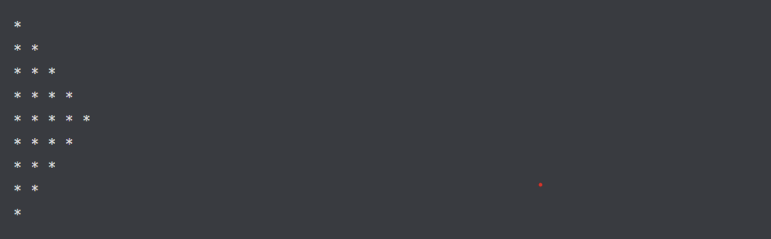

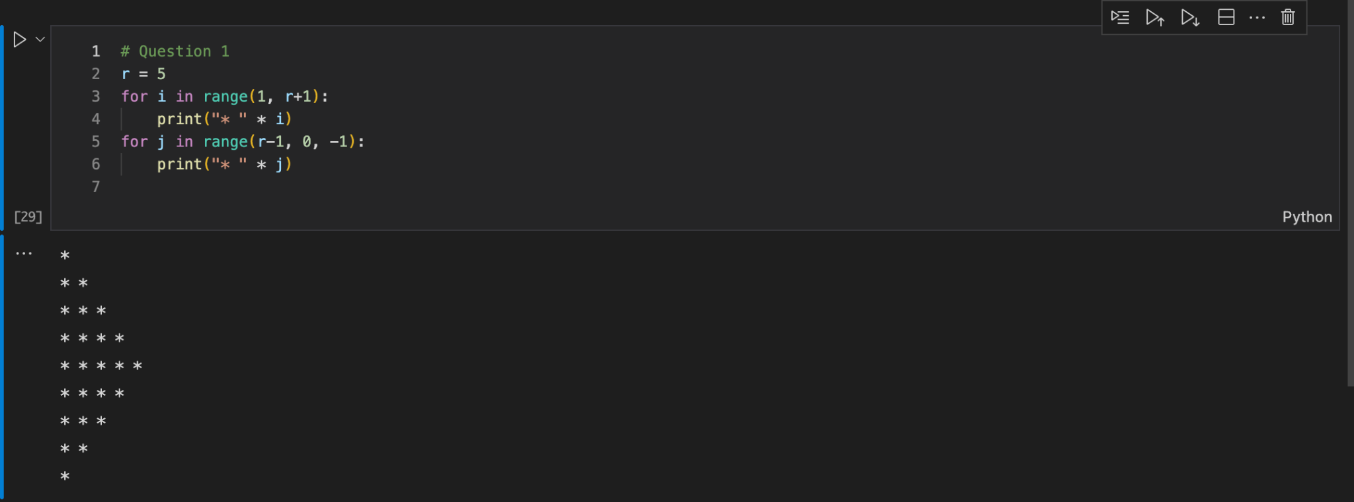

Explanation:

I used 2 loops, one which goes from 1 to 5 and other from 4 to 1 and printed the stars using * syntax inside the print function itself.

**Question 2**

Use looping to output the elements from a provided list present at odd indexes. my_list = [10, 20, 30, 40, 50, 60, 70, 80, 90, 100]

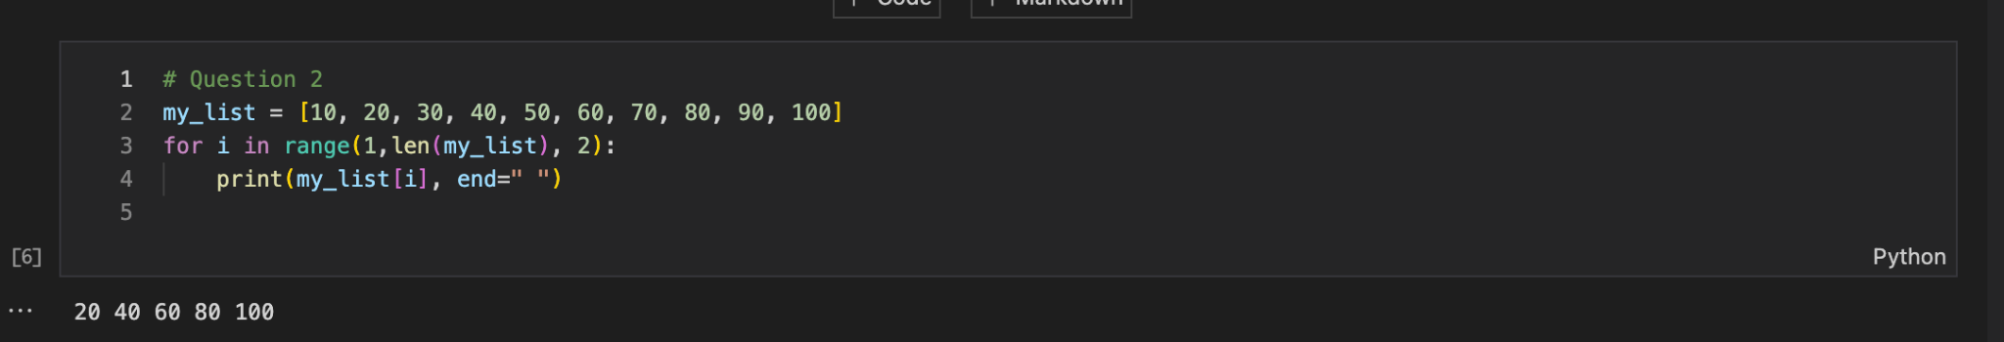

Explanation:

Here I used a for loop along with the range function to loop through the list and incremented by 2 in each step.

**Question 3**

Write a code that appends the type of elements from a given list.

Input x = [23, ‘Python’, 23.98]

Expected output

[23, 'Python', 23.98]

[<class ‘int’>, <class ‘str’> , <class ‘float’]

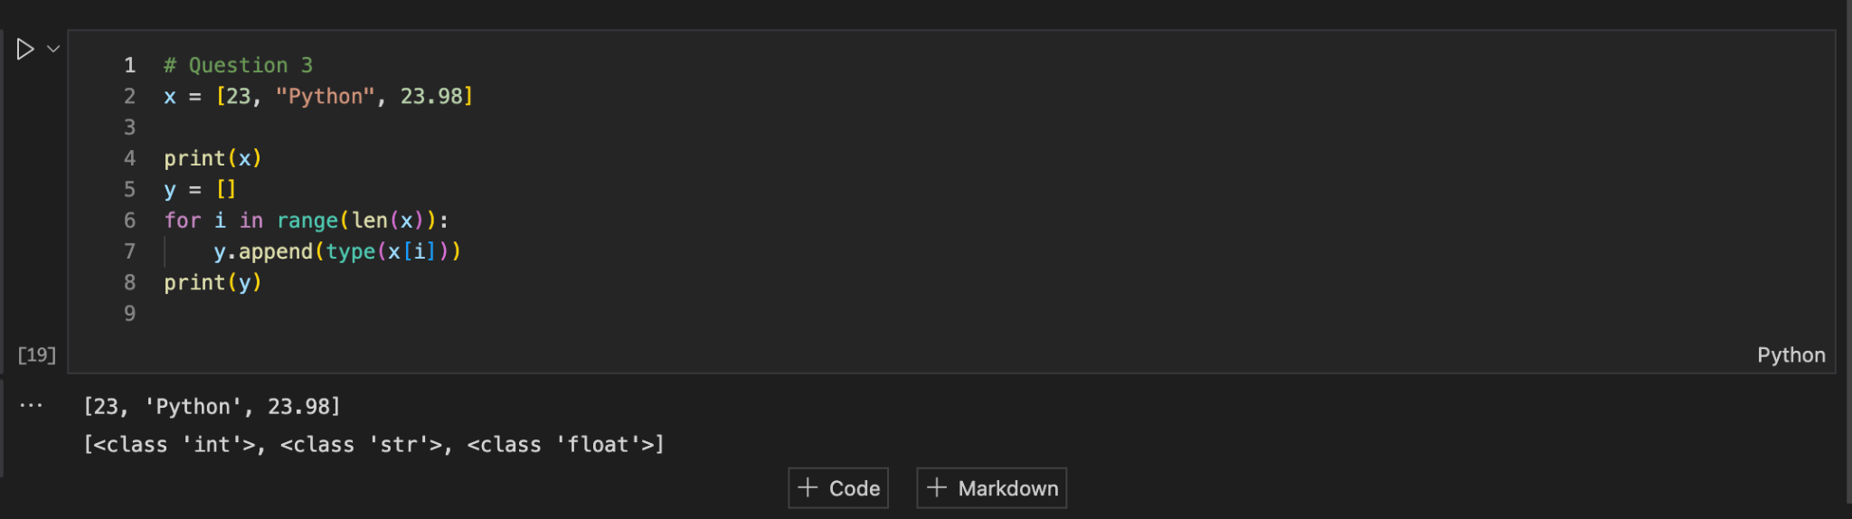

Explanation:

Here, To generate a list that contains the data type of the elements in list x, I looped through the list and I appended the type of the item to the new list.

**Question 4**

Write a function that takes a list and returns a new list with unique items of the first list. Sample List: [1,2,3,3,3,3,4,5]

Unique List: [1, 2, 3, 4, 5]

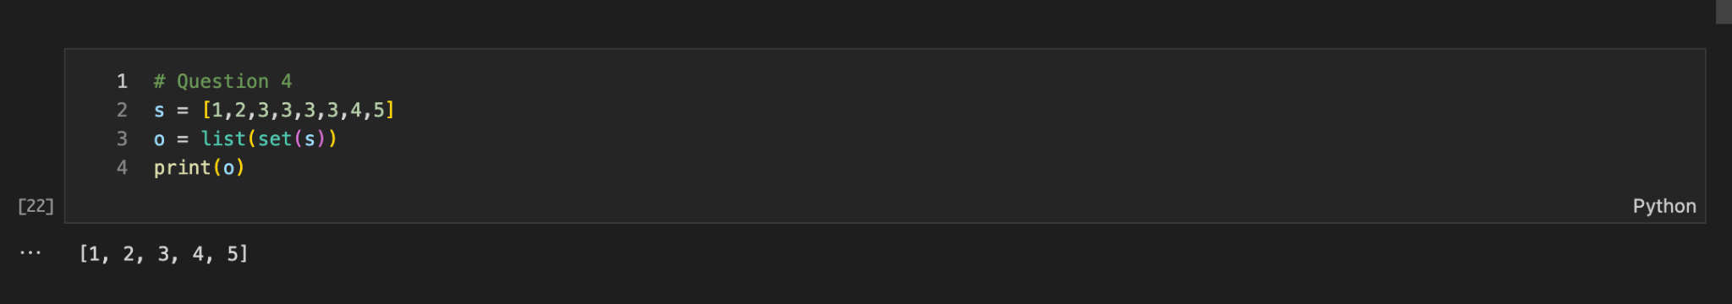

Explanation:

Here, to generate unique elements from a list of numbers, I used the set function to create unique numbers and used list function to convert back to list.

**Question 5**

Write a function that accepts a string and calculate the number of upper-case letters and lower-case letters.

Input String: 'The quick Brown Fox'

Expected Output: No. of Upper-case characters: 3

No. of Lower-case Characters: 12

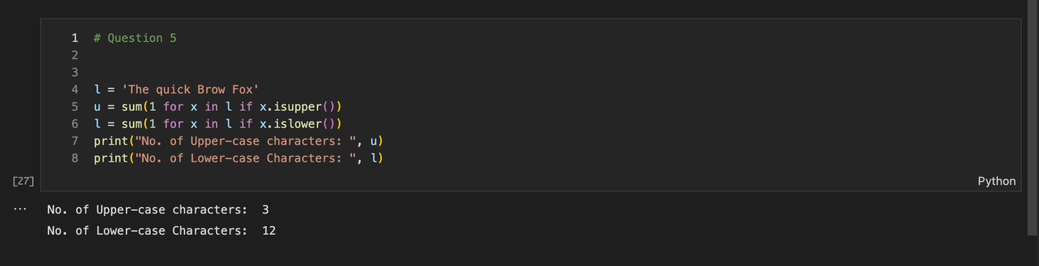

Explanation:

Here, I used the for loop to loop through each letter of the string and used isupper and islower functions and summed up the result so that we can get the final count of uppercase letters and lowercase letters.